CECS 201 Xilinx ISE 14.7/Nexys 3 Spartan 6 Tutorial
By Dr. Xiaolong Wu
Objective
This tutorial will give you exposure to many of aspects of the overall design flow. In this process you will be exposed to three major Parts (9 steps): Design Entry, Simulation or Verification, and Implementation.
- design entry via schematic capture (or possible by Hardware Description Language (HDL) or even by a State Diagram in the case of sequential circuit);
- Simulation also can be performed at two levels – Functional Simulation or Timing Simulation. Functional simulation simply checks whether the design will function or behave as expected. It does not bother about timing issues (It is also called behavioral simulation by some). Timing simulation is obviously more involved;
- Implementation via a NEXYS FPGA prototyping board from Digilent.

This tutorial shows you how to create, using schematic-based entry, a 3-input combinatorial circuit. Specifically, this tutorial implements the following function: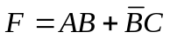. Even this function is trivial and the idea of this tutorial is to familiarize ourselves with the Xilinx tools.

Step 1 - Start ISE and Create a New Project
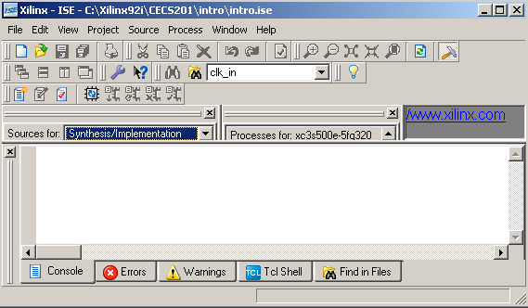
To start the Xilinx ISE tools, click on the Start→All Programs→Xilinx ISE Design Suite XX.X→ISE Design Tools ->Project Navigator. This will bring up a screen similar to that of Figure 1.
ISE may come up with the last project opened by the tool but a new project needs to be started for the tutorial. To create a new project, click on the menu File->New Project…. This will bring up a small dialog box with information about the new project. In the "Project Name" box, type intro, the name will be used for this introductory tutorial.
Figure 1 - ISE Project Navigator.
- Now, select an appropriate location for all the project files in the “Project Location” box, preferably save to the local machine and then copy to your Z: drive whenever you leave the lab (otherwise you will lose all information).
- Lastly, choose “HDL” for the “Top-Level Source Type” (Figure 2), then click “Next”.
Now we need to setup the Device details. Use the drop down menu for each item and select. Depending on the Board, we need to enter different data.
- For the “Product Category”, you may select “General Purpose”;
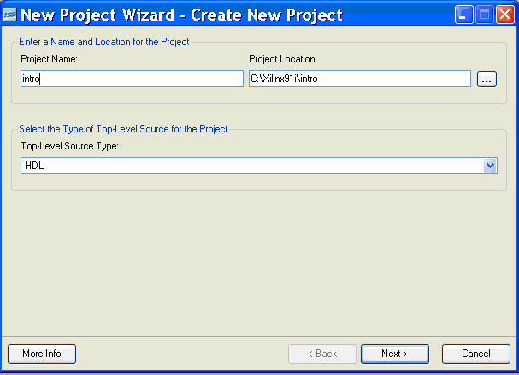
- For the Nexys 2
  - Set “Family” to “Spartan6”
  - Set “Device” to “XC6SLX16” (you can find which one to use by looking at your board)
  - Set “Package” to “CSG324”
- Set “Speed” to -3
- Set “Synthesis Tool” to “XST (VHDL/Verilog)”
- Set “Simulator” to “ISE Simulator (VHDL/Verilog)”
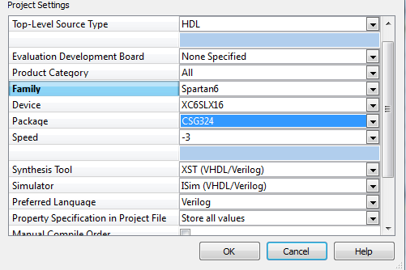
Figure 2 - New Project Dialog Boxes
- Set “Preferred Language” to “VHDL”

- Click “OK” and the click “Finish”, then you will see the following Figure 3.
- Make sure you choose correct setting; otherwise you will meet some weird error later!!! If you happen to see some error in the remaining of the project, the first thing needed to do is to check whether you’ve selected the correct setting.
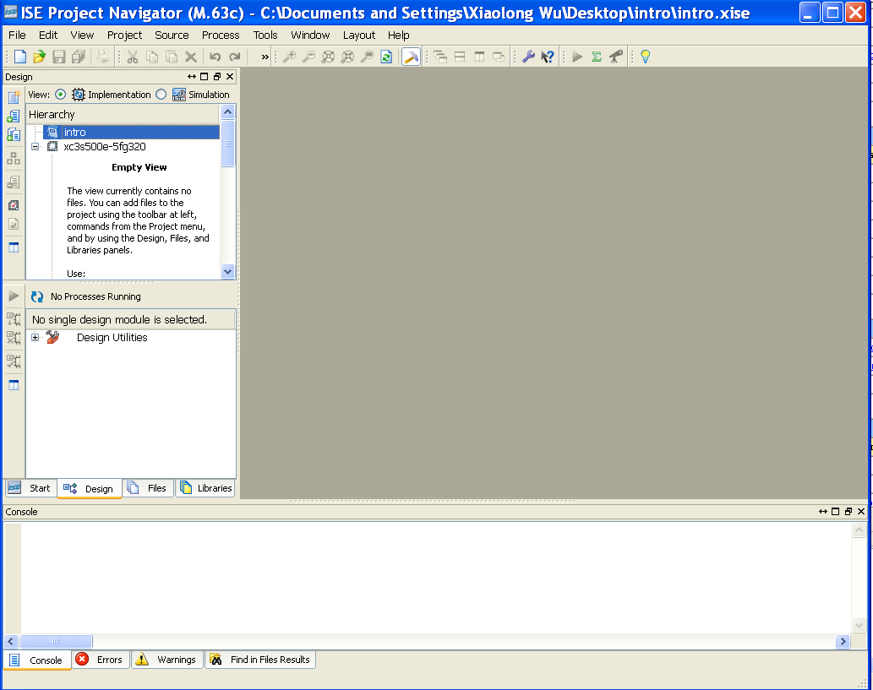

Figure 3 - New Project Dialog Box.
Part A - DESIGN ENTRY:
Step 2 - Add a New Schematic Source File
Now the project has been created with the proper attributes, a schematic capture file needs to be added to implement the simple combinational circuit. We need to
- Click on the menu Project->New Source. This will bring up a small dialog box with several choices for design entry
- Select the “Schematic” (second one) choice from the left box
- Type “intro” in the “File Name” box
- Be sure that the file location is in your project directory
- Make sure “Add to Project” checkbox is selected
- Click on “Next” → “Finish” to add the schematic source and start schematic capture program. See Figure 4.
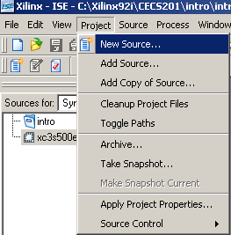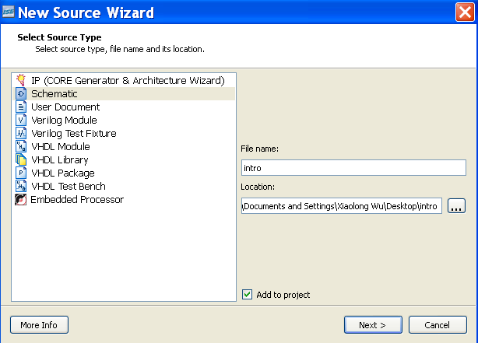
Figure 4 - Add New Source File.
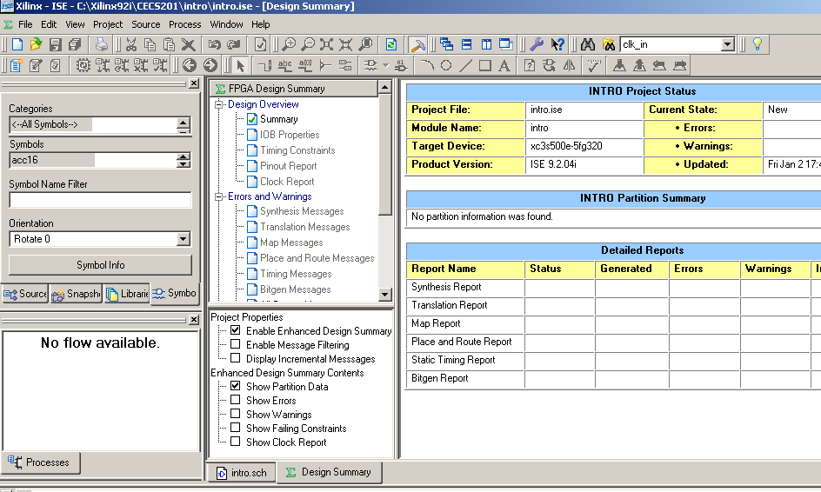
Now you will see a source file added to your project on your Project Navigator window (see Figure 5). And will launch the Schematic Editor (see Console at the left bottom) and will give you a summary of the project. There are two “choice” right above the Console window, “intro.sch” and “Design Summary”. Make sure select “intro.sch”. In the left, there are two sections. The top left section normally deals with Sources for the Project and the bottom left section deals with the Processes for the Source. For schematic entry, we need to enter logic symbols and so you will notice that the symbols tab is selected. The bottom section has Options tab selected. Make sure to click to “Zoom in” icon to enlarge the schematic capture window so that it will be easier for you to manipulate the schematic.

Figure 5 – Blank Schematic Capture.

Step 3 - Schematic Design Entry
Each Schematic Capture Design entry consists of “Instantiating/Adding” logic components (such as add2, or2, inv, etc), Wiring or Interconnecting, Naming the nets, and providing Input/Output markers to connect them to pins in the actual prototyping board.
In order to implement the given combinational equation, we are going to need to insert various basic logic components, such as AND, OR, and NOT (Inverter), as well as Input/Output buffering components and Input/Output markers, used to hook the internals of the design to the outside world.
There are 6 small steps implemented in 8 sub steps to create a schematic:
- Place all logic components (select “Symbols” in the right (one of four options))
- Select “Logic” in the Categories Box (located in the upper left corner)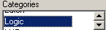
- Select “and2” in the Symbols box (right below the Categories Box). To quickly reach “and2”, you can type “and2” in the Symbol Name Filter (right below the Symbols box) 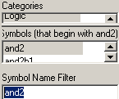
- Move the mouse to the work space and the “and2” symbol will come along with the mouse. To place the symbol on the design, left-click once somewhere near the center. Be sure that you do not left-click multiple times as this will place multiple and2 symbols on the sheet. Hitting the Esc key on the keyboard will take you out of the symbol insert mode. 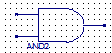
- Repeat this procedure to place one more “and2”, “or2”, and “inv” symbols on the screen as shown by Figure 6.
- Wiring all components:
Now all logic components are in place, we need to provide connections for inputs and outputs. We will stretch the wires of all gates and then connect them to the input and output pads or markers.
- To draw the wires or nets, you may also click on the Addwire icon (picture of a downward step and a pencil). Or you may click on the menu Add->Wire or Ctrl W. Place it at one of the inputs of the ‘and’ gate. You will see 4 small squares. Left-click and drag to the left for some distance. Release the mouse. You will see a red termination on the wire indicating probably that the connection is incomplete. (I guarantee that you will have some error message later if you missed this step) Repeat and finish adding wires to all inputs/outputs, meanwhile, finish wiring between different gates. Your schematic should look like Figure 6.
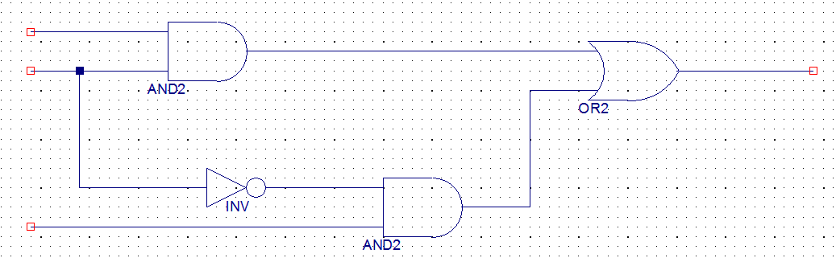
Figure 6 – Schematic Design Entry after adding all Logic Components.

- Naming the Nets:
- We need to add a net name to each of the hanging I/O nets that were just created.
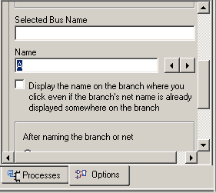
  - Click on the Addnetname icon (a downward step with abc written on it). You may also click on the menu Add->Net Name or Ctrl D.

  - The place to type in all the net names for your inputs and outputs is the “Name” box right below the “Selected Bus Name” box in the “Processes” window (left middle side of the window). Enter A in the “Name” box, and hit the enter key. Move the mouse (A comes along) and place “A” near the red mark on the net. Then click. Hit the escape key. Similarly name B, C, and F. The net names may be too small to see. You can select View, Zoom and In or just click on the Zoom In icon (a lens with a + sign in it) to see the schematic clearly. Now your schematic should look like Figure 7.
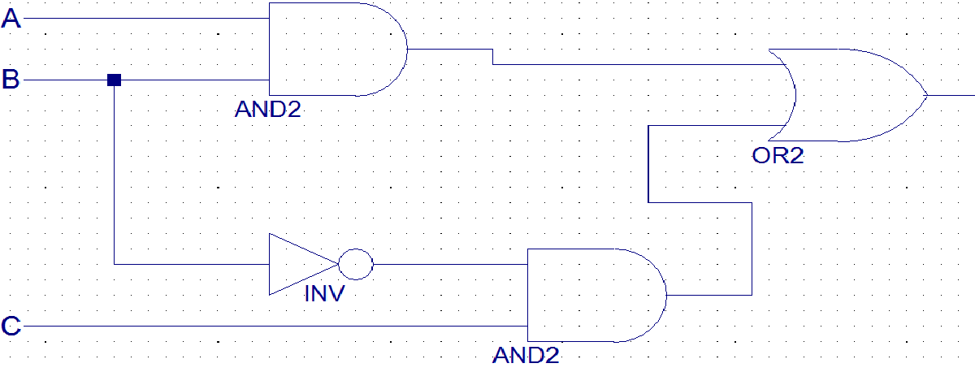

Figure 7 – Schematic Design Entry after Naming the Nets.

- Adding I/O Marker:
The last step in finishing the design is to add the I/O markers.
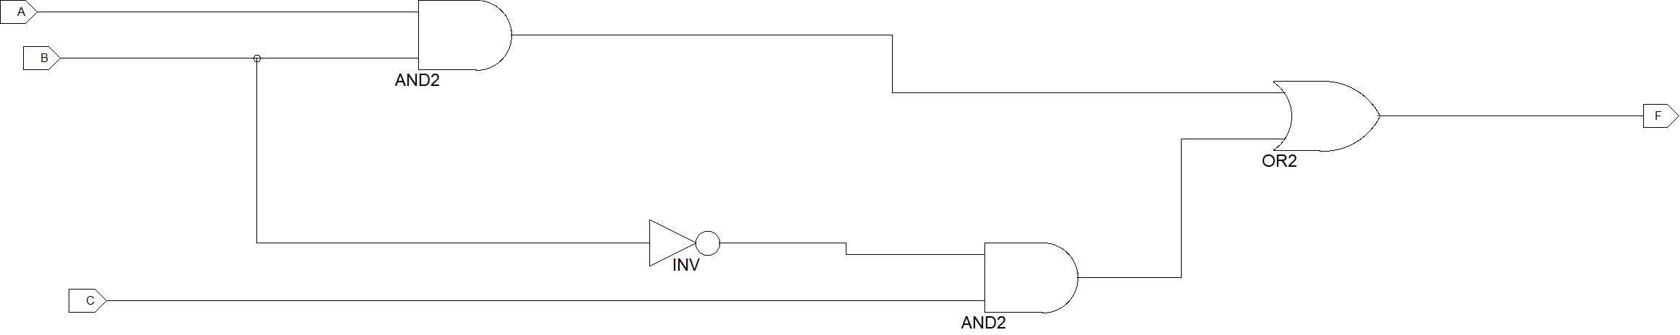

Figure 8 – Schematic Design Entry after Adding I/O Markers.

- Click on the Add I/O marker icon . You may also click on the menu Add->I/O Marker or Ctrl G. The place to select the appropriate I/O Markers for your inputs and outputs is the "Options" pane on the left hand side of the screen. Click on the appropriate "radio button" (right below the “Process” window) for either adding an “input marker” or an “output marker”. This creates a symbol to come along with the mouse. Select the Input type. Move the mouse near the name. Until you see four squares box. Left click. Repeat this for the other named nets B, C, and F (Be sure and select the Output type for F). In later projects, if you find the schematic is crowded for convenience of connection, you may rotate the marker icon by 90 degrees with Rotate in the Edit menu or Ctrl R. Now your schematic should look like Figure 8.

- Check Schematic:
Now that the design is complete, you can check to make sure that your design is free of basic connection errors.
- Click on the menu Tools->Check Schematic. If you have no errors, you should see a message to that effect in the console at the bottom. If there is an error, use the information in this window as a guide to help solve the error.

- Add Your Name and Save File:
Once you are done, go to Add menu and choose Rectangle and place it at the bottom right corner. You may zoom out (lens with - sign) to view the whole page. Then choose Text in Add menu. The Option box turns to ‘Add Text Option’ box opens below the Symbols box. In the “Text Value” box, you may type your name. You can change the Text Size to 64. Hit enter key. Move the mouse (the text will come along) and place it inside the rectangle. Hit Escape. Similarly add Lab #, Date, Revision # etc. To print the schematic, go to File, Print Setup and choose Landscape for orientation. You can print preview. Then print (assuming you have a print account). Then click on File->Save (or Ctrl S) to save the schematic.

Part B –Simulation:
This involves generating the test inputs and verifying outputs to see whether they are as expected.
Step 4 - Generating the Testbench
There are some sub steps needed to generate the testbench (change from Implementation to Simulation in the upper left corner).
- On the left boxes, get back to “Sources” and “Processes” windows. Make sure that “intro.sch” is highlighted in “Sources box” in Sources area (upper left corner) (Figure 9). In the “Processes” window, double click on “Create New Source” or you can go to Project ->New Source.
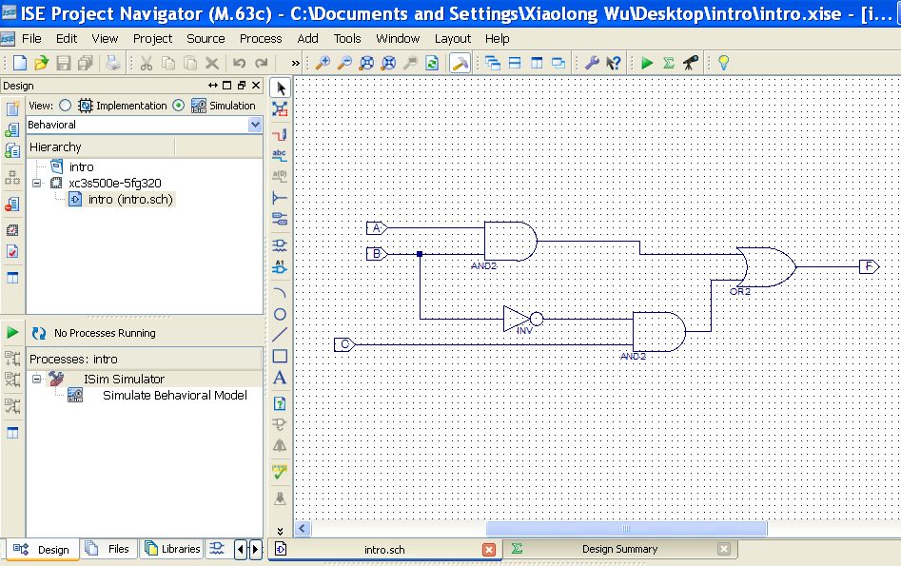
Figure 9 – Generating Test Beach before Double Click “Create New Source”.
- In the dialog box called the “New Source Wizard – Select Source Type” which asks us to select a source type, select the type “Verilog Test Fixture”. Give it a file name “intro_tb”. Location will be default. Make sure “Add to project” is selected. Check figure 10.
- When the “Source File” window appears, “intro” should be selected already (it will be the only available selection). Click on "Next". It summarizes New Source Information. Click "Finish".
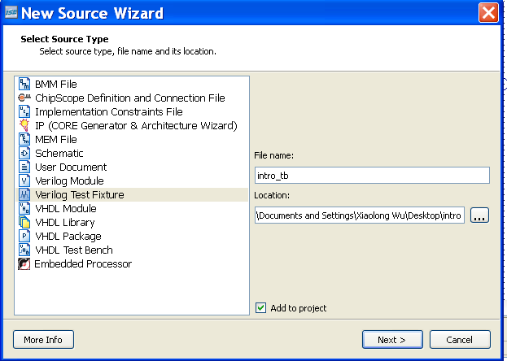
Figure 10 – Generating Test Beach right after opening “Create New Source” window.
- Update the Initialize section with the following codes (make sure all Inputs/outputs_A/B/C/F or D symbols are matching)
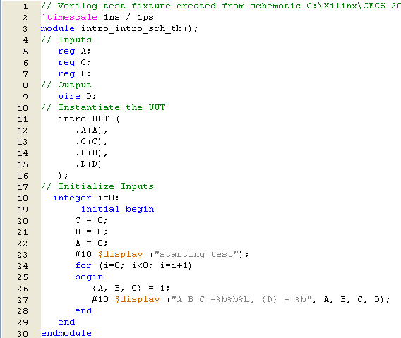

Figure 11 – Generating Test Beach when defining “Initialize Timing and Clock Wizard”.
// Initialize Inputs
integer i=0;
initial begin
C = 0;
B = 0;
A = 0;
#10 $display ("starting test");
for (i=0; i<8; i=i+1)
begin
{A, B, C} = i;
#10 $display ("A B C =%b%b%b, {F} = %b", A, B, C, F);
end
end

- Click “Behavioral Syntax Check” and looks similar to figure 12.
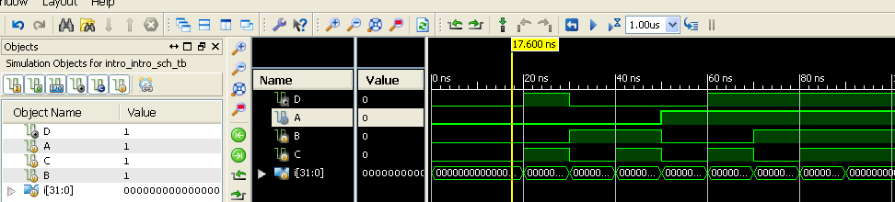
Figure 12 – Generating Test Beach after Generating the Testbench.

- Assuming that input A is the most-significant-bit, the truth table for this circuit is as follows:
A | B | C | F
0 | 0 | 0 | 0
0 | 0 | 1 | 1
0 | 1 | 0 | 0
0 | 1 | 1 | 0
1 | 0 | 0 | 0
1 | 0 | 1 | 1
1 | 1 | 0 | 1
1 | 1 | 1 | 1

Step 5 – Functional Simulation of the Design
- Double click “Simulate Behavioral Model”
. 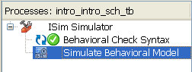
- A new window will pop up as follows:
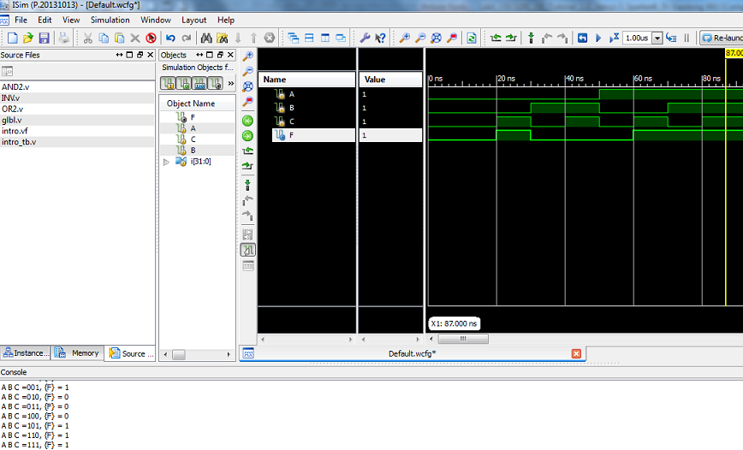
- Simulation Results are as follow and check all EIGHT combinations.
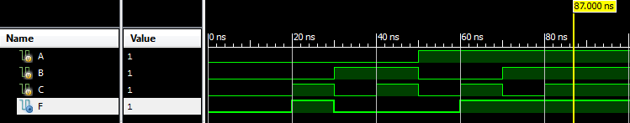
Figure 14 – Simulation Results.

Part C –Implementation: (not for CECS 225 class)

Implementation involves taking the netlist files from design entry and creating an optimized structure for a specific FPGA in a specific configuration. The steps involved include the following:
- assigning pin numbers to the circuit
- generating the bit stream file which holds the configuration information for the FPGA
- downloading it to the FPGA board
- Finally of course testing the outputs on the prototype board.
Step 6 - Assigning Pin Numbers
- We need to enter the desired locations (pin numbers) needed to fit the design to the capabilities of the board. To do this, we must create an "Implementation Constraints File." Switch back to “Implementation” in the pull down menu in the right top of the Sources box. You will see intro.sch selected.
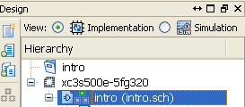

- In the Processes box, double click on “Create New Source”. In the Dialog box called the “New Source Wizard”, Select Source Type “Implementation Constraints File”. Give the file name as intro_icf. Click "Next." When the "Associate Source” window appears, intro should have already been selected (it should be the only available selection). Click on "Next" and then "Finish" the Summary window. If you expand intro in Sources, you will see intro_icf.ucf added. Select it. (see Fig. 15)
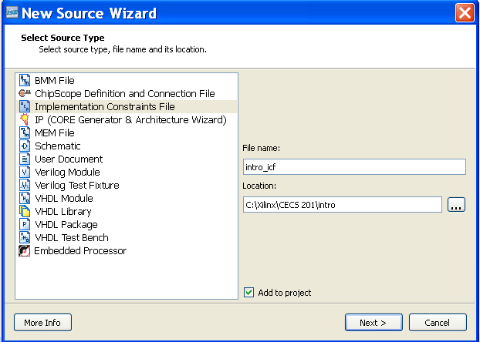
Figure – 15

- Type the following codes in the window.
- NET "A" LOC = "K18";
- NET "B" LOC = "H18";
- NET "C" LOC = "G18";
- NET "F" LOC = "J14";
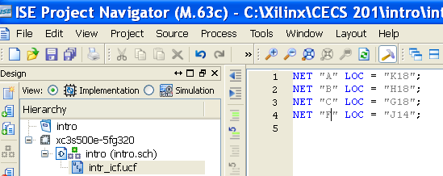
Figure – 16
- C is Slide Switch SW0 (least significant) whose location is G18
- B is SW1 whose location is H18
- A is SW2 (most significant) whose location is K18
- F is LD0 (least significant) whose location is J14 (forNexys2).
- Save
- To run the full implementation, in the “Sources” window, select (with one click) the intro.sch. In the “Processes” window, double-click on “Implement Design”. You should see a lot of messages getting written in the bottom message window (console). The program tries to translate and then map schematic diagram to the actual gates in the gate array chip and then to the board. Hopefully it ends with the message “Generate Post-Place and Route Static Timing” completed successfully”. Ideally, you should see a green check mark against Synthesis-XST and Implement Design. If you see a yellow exclamation mark that means there is a warning posted. If you scroll the console window, you can see warning details. (see Fig. 18)
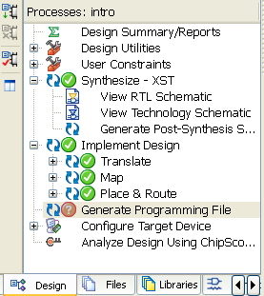

Figure - 18
Following figure shows all pins for 7-segement displays, slide switches, push button switches, and LED’s. If the pins in your board are different from those in the following figure, you should follow the following figure.

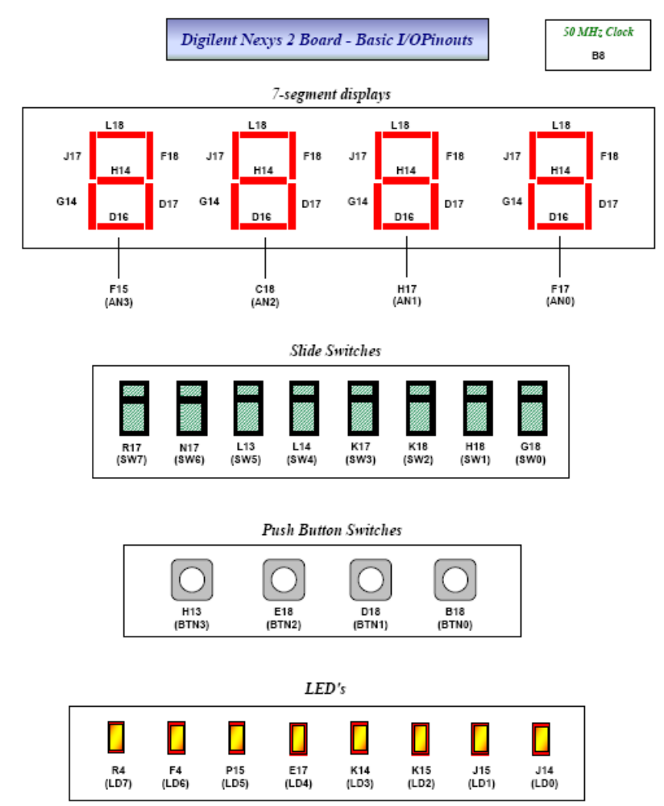

Step 7 - Generating the Bitstream File
We need to create a Bitstream, (a binary file x.bit file) that holds the configuration information for the FPGA.
- First, you will need to set the configuration clock for the Bitstream. The Spartan3 board uses JTAG (Boundary-Scan) to configure the device.
- To set the configuration clock to JTAG, right-click on the “Generate Programming File” in the Processes window and then select “Properties”. Now, In the “Process Properties” window, select the “Startup Options” tab, and for “FPGA Start-Up Clock”, select “JTAG Clock” with pull down menu. Click Apply and OK to accept the new option and return to the Project Navigator.

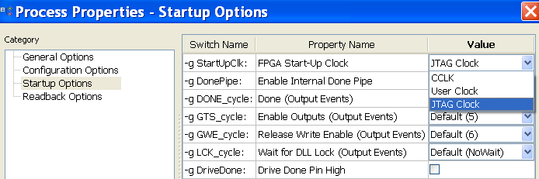
- Now double-click on the “Generate Programming File” process in the Processes window. If the Bitstream file was created correctly, you will see “Process Generate programming file completed successfully” message and you'll see a green check mark next to the Generate Programming File process.

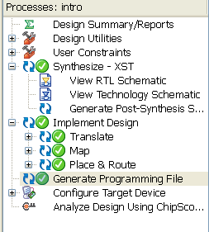

Step 8 - Downloading the Design to the FPGA Board
Once you've created your Bitstream file, it is time to download it into the board.
For NEXYS 2 and NEXYS Boards:
Before connecting, we need to ensure that certain jumpers are in place.
- Power source for the board for USB needs shorting the appropriate pins at J4. (JP7 for Nexys)
- There should be a cable bypass jumper on the JTAG header at J6 to connect TDI and TDO signals
- Mode Select Jumper JP3 (JP9 for Nexys) must be towards PC via JTAG and not towards ROM (Platform Flash). In Nexys board, JP10 should be 3v3
Next, you need to:
- Connect the board through USB cable. If there is a ON switch, turn it on (It helps you know)
- We need to invoke a tool called Export from the Adept set of tools. In “All Programs-> Digilent-> Adept-> Adept”. USB will be selected for connection.

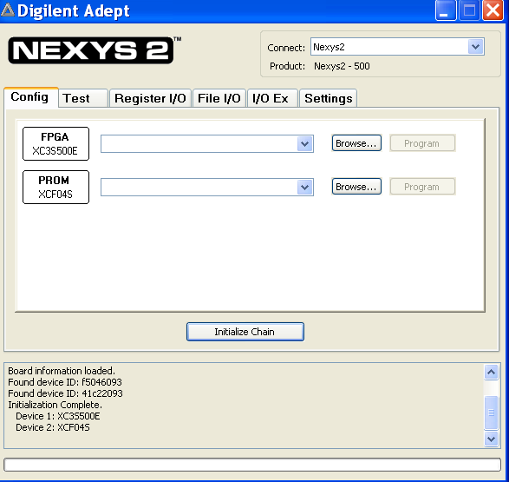

- Click on “Add File” at left bottom. Select the appropriate bit file (intro.bit) (by browsing the folders).

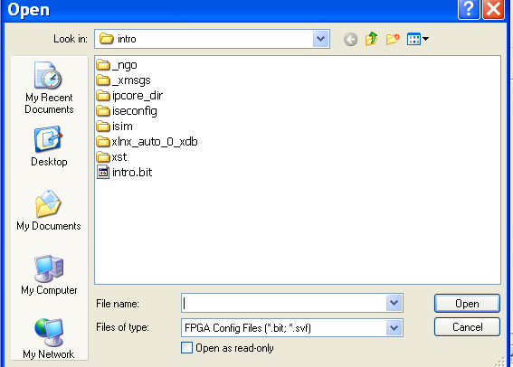

- Click on “Initialize Chain”.
- Then click on “Program”. If the programming is successful, we will get a Finished message in a dialog box and in the console below.

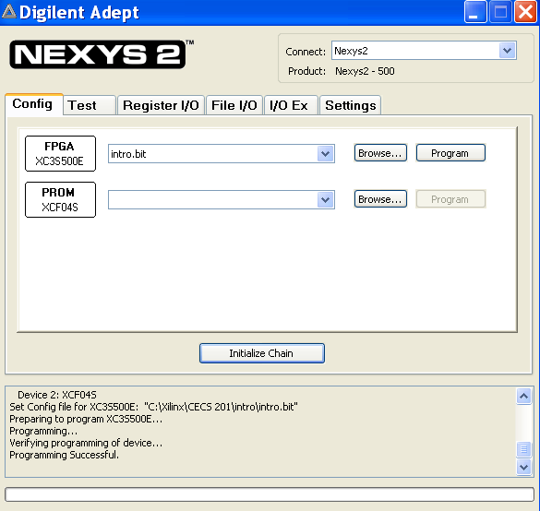
Step 9 - Testing on the Board
You may now test the various combinations of input patterns on the three slide switches on the board. The LED should light up for certain combinations. In the Project Navigator, to save the work, go to File and “Save project as” or “save all” and exit Project Navigator. Then move the entire folder andgate to your Z drive in Z:\Projects\201\ folder. (Next time you start, move the entire Projects\201\ folder from Z to E and work. Later move it to Z again etc.).

